Celebrate YOU: Social Media Content Planner
For all assets please visit adf.org.au/campaign-kits/celebrate
 | Facebook/LinkedIn | Twitter | Instagram
Video/Still #1  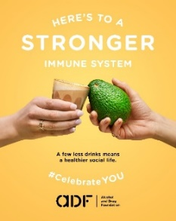 | In times like these, your best defence is regular exercise, more fresh food, and less to drink. | A fighting-fit immune system is important now more than ever. Celebrate your health with exercise, more fresh food and less alcohol. More info: adf.org.au/celebrateyou #CelebrateYOU | Keeping a strong and healthy immune system is so important in times like these. There are some simple things you can do to strengthen your body’s defence like regular exercise, eating a well-balanced diet with lots of fresh produce and reducing the amount of alcohol you drink.  To find out more see @alcoholdrugfdn  #CelebrateYou
Video/Still #2  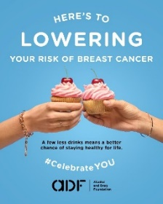 | The list of cancers caused by alcohol is long, but you can shorten the odds in your favour by drinking less. | Cancer is complicated, but we do know you can help to stack the odds in your favour by drinking less. Find out more: adf.org.au/celebrateyou #CelebrateYOU | Cancer is complicated and the list of different types caused by alcohol is long. But you can help stack the odds in your favour by cutting back your alcoholic drinks.  To find out more see @alcoholdrugfdn  #CelebrateYou
Video/Still #3  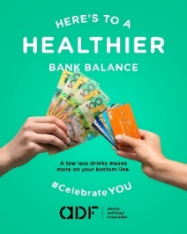 | If you want to top up your savings, it pays not to top up your glass. | Struggling to save money, but regularly restocking your alcohol cupboard? It all adds up. Cut back a little now and let your bank account reap the rewards (P.S. you’ll feel better too!). Find out more: adf.org.au/celebrateyou #CelebrateYOU | If you’re feeling financially challenged, keeping the fridge topped up with a few bottles of your favourite alcoholic drink might not be the best strategy. Try cutting back on the amount of alcohol you buy (and drink) and watch your bank balance grow. It can be surprising how it all adds up. (P.S. you’ll feel better too!).  To find out more see @alcoholdrugfdn  #CelebrateYou
Video/Still #4  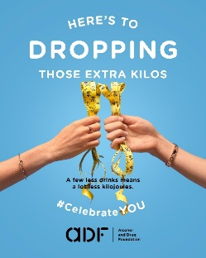 | If you’re looking to cut kilojoules, cutting down on the amount of alcohol you drink is a great place to start. | If you’re looking to cut kilojoules, cutting down on just a few alcoholic drinks can make a big difference. Find out more: adf.org.au/celebrateyou #CelebrateYOU | If you’re thinking about ways to ways to drop an extra COVID kilo or two, cutting down on just a few alcoholic drinks could be a great place to start.  To find out more @alcoholdrugfdn  #CelebrateYou
Video/Still #5  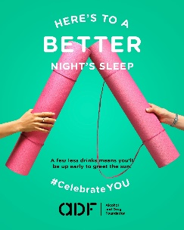 | Alcohol doesn’t actually help you sleep, it just seems that way. If you want to get more quality  shut-eye, start by taking a look at reducing the amount you're drinking. | Alcohol and sleep do not go hand in hand. If you’re keen to get more quality shut-eye, think about reducing the amount you're drinking. Your well-rested body will thank you! More info adf.org.au/celebrateyou #CelebrateYOU | Want more quality shut-eye? Could be time to cut back the alcoholic drinks.  While alcohol in the blood can sometimes help us nod off, it eventually stops us from enjoying a deep and revitalising rest.  To find out more see @alcoholdrugfdn  #CelebrateYou

